# 20220826

## 7.1 Key words

|  |  |  |
| --- | --- | --- |
| O to D, Demand | Fixed point formulations | All or nothing assignment |
| **Arc** flow / link/ lead cost | User equili-brium  Wardrop principle | **BPR** function:  Monotone increasing |
| arc cost function | Deterministic / static model | Volume over capacity |
| Pod cost, but flow  Path cost , path flow | Dynamic model | Method of successive average (MSA) |
| Total cost : daodao cost | Variational Inequality (VI) | Integral积分 |
| shortest path  short spot | Linear, curve, quadratic | Alternative: 可供选择的事物 /ɔːlˈtɜːnətɪv/ |
|  | Descent direction | Contraction收缩 |
|  | Extreme point | Derivative /dɪˈrɪvətɪv/ 导数 |
|  |  |  |
| formula | Derivative 导数 | Jacobian matrix |
| calibrate | Synthesize 合成  Combines | Strictly positive definite congestion function assumption |
| Diagonal对角 | smoother |  |
| Symmetric对称  Asymmetric 非对称 | Obtain əbˈteɪn | the x1’s square |
| Disutility 无用 | Bagels 面包圈  beɪɡlz | PCU  Passenger Car Unit |
| array |  |  |
| Junction  intersection | Under-saturation：未饱和  **saturation** | HCM  High capacity manual |
| Conflict冲突 | manoeuvres /məˈnuːvə(r)/  熟练 ma-nuoeu-vres | Unit of measurement  计量单位 |
| Deterministic确定的  dɪˌtɜːmɪˈnɪstɪk/ |  |  |
|  |  |  |
| 20220825 |  |  |
| separate | Choose  alternative | Mate 同事  colleague |
| Freight trade 货物 | Per se 本身 | Forecast |
| Harbor 海港 | exercise | Discrete function  Continuous function |
| [annunciate](javascript:;)  /əˈnʌnsɪˌeɪt/  foreshadow or presage | Ratio , percentage | Interval  Minus 减  Add /plus 加  Multiplies 乘  Division 除  Square 平方  Square root 平方根 |
| Stimulus /ˈstɪmjələs/  any stimulating information or event; acts to arouse action | | Amplification  /ˌæmplɪfɪˈkeɪʃn/  a few remarks added in amplification and defense |

## 7.2 [frequently-used](javascript:;) [expression](javascript:;)

|  |  |  |
| --- | --- | --- |
| **You know** | **Then** | Minus, plus, multiply |
| **Just for explain** | I want to present to you that ** | 收缩：contraction |
| Can I ask a question | Now, I will just show you that | Convergence, respect |
| Why do we need ** | Not only .., but also .. | robustness /rəʊˈbʌstnəs/ |
| You know what I mean | You really grasp the means | Uniqueness juˈniːknəs/ |
| actually now |  | Symmetric 对称 /sɪ'metrɪk/ |
| And then…. |  | Co-e-fficient系数 ˌkəʊɪˈfɪʃ(ə)nt |
| ** depends on serval factors |  |  |
|  | Did I answer your question? | I hope this to make sense for |
|  |  |  |
|  |  |  |
|  |  |  |
| 20220825 |  |  |
| Professor, I got it.  我懂了 | Any other question? | Many choices are heavily based on the behavior of people |
| We define the way to | The average of height is 176 centimeters.  ratio | I have holiday to go abroad or I stay in my own country |
| Path probability |  | You have scrolled the height of Mount Everest. 喜马拉雅山  /skrəʊld/ /ˈevərɪst/ |
|  | Just give me a couple of minutes | We don’t have any excel presentation, I don’t see the sharing screen. |







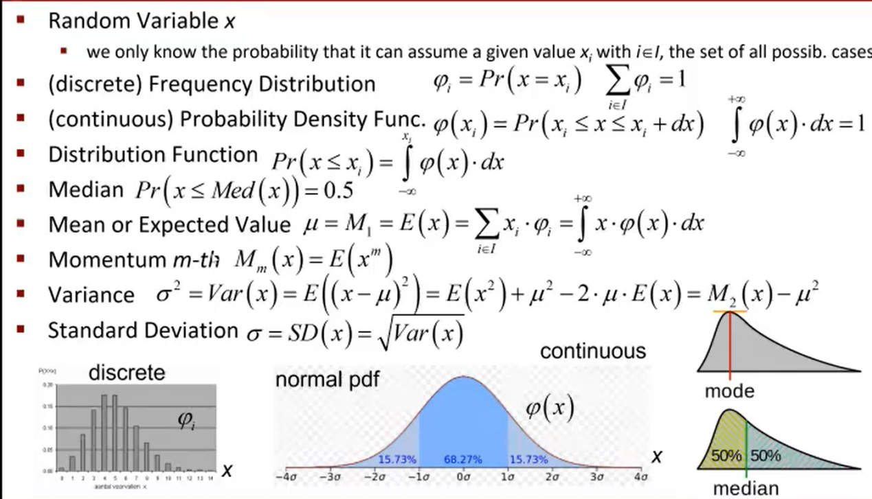

<https://neal.fun/deep-sea/>

: Phi I is equal to Probability of my random variables acts being equal to value xi.

 sum over all the Phi of given is equal to 1.

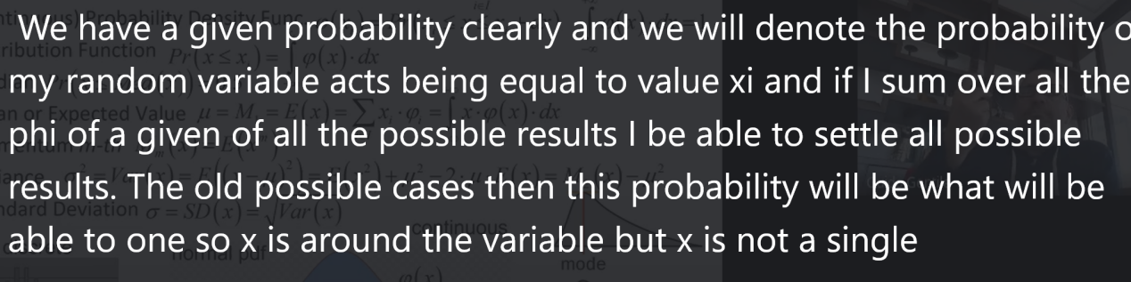

Momentum  冲量

the car's momentum carried it off the road an impelling force or strength



Just give me a couple of minutes



We don’t have any excel presentation, I don’t see the sharing screen.



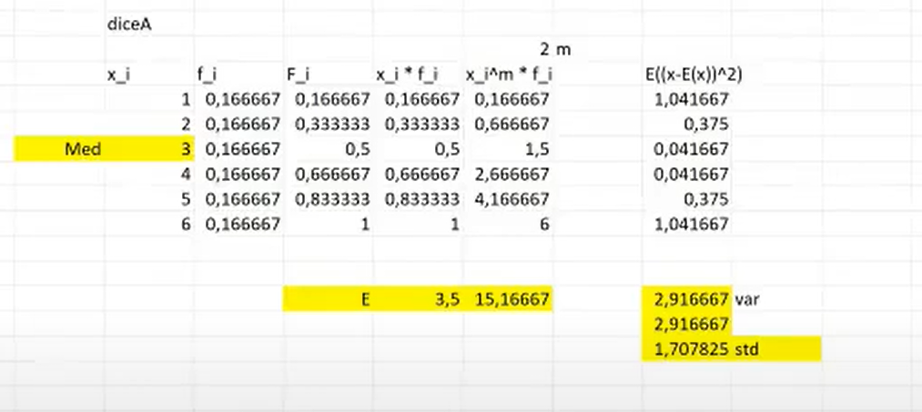

# 20220826

## 7.1 Key words

|  |  |  |
| --- | --- | --- |
| Surplus /ˈsɜːpləs/  residual | Elaboration /ɪˌlæbəˈreɪʃ(ə)n/ 详尽阐述  the result of improving something;  developing in complex and painstaking detail | |
| associated /əˈsəʊsieɪtɪd/  relative | Marginal /ˈmɑːdʒɪn(ə)l/ 边际  at or constituting a border or edge | Isolated /ˈaɪsəleɪtɪd/  not close together in time |
| Inclination /ˌɪnklɪˈneɪʃn/  Tendency /ˈtendənsi/ |  | Systematical ˌsɪstəˈmætɪk(ə)l/ |
| Correlative /kəˈrelətɪv/ | Differentiable /ˌdɪfəˈrenʃɪəb(ə)l/  possessing a differential coefficient or derivative | Monotone /ˈmɒnətəʊn/  an unchanging intonation |
| Decay dɪˈkeɪ/ the process of gradually becoming inferior | Density /ˈdensəti/ | Infinity ɪnˈfɪnəti/  无穷 time without end  [finitude](javascript:;) 有限的 ˈfɪnɪˌtjuːd/ |

## 7.2 [frequently-used](javascript:;) [expression](javascript:;)

|  |  |  |
| --- | --- | --- |
| If we assume | I hope that this makes the case and lets you understand a little bit the meaning of this concepts that we find there. | |
| Can you repeat the **? |  |  |
|  |  |  |
|  |  |  |
|  |  |  |
|  |  |  |
|  |  |  |
|  |  |  |



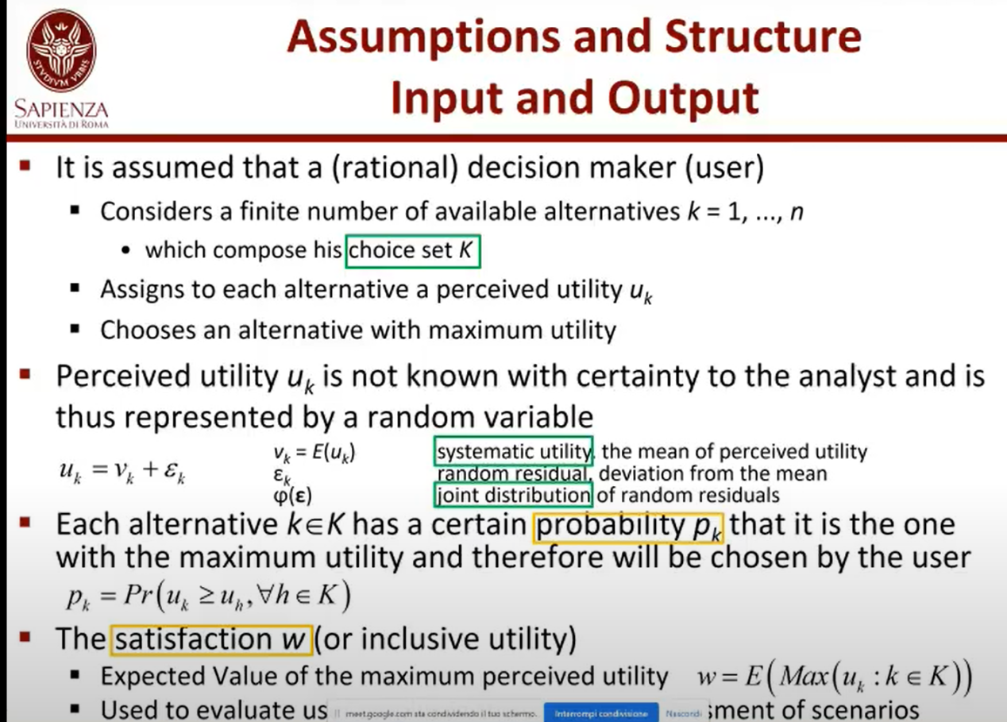

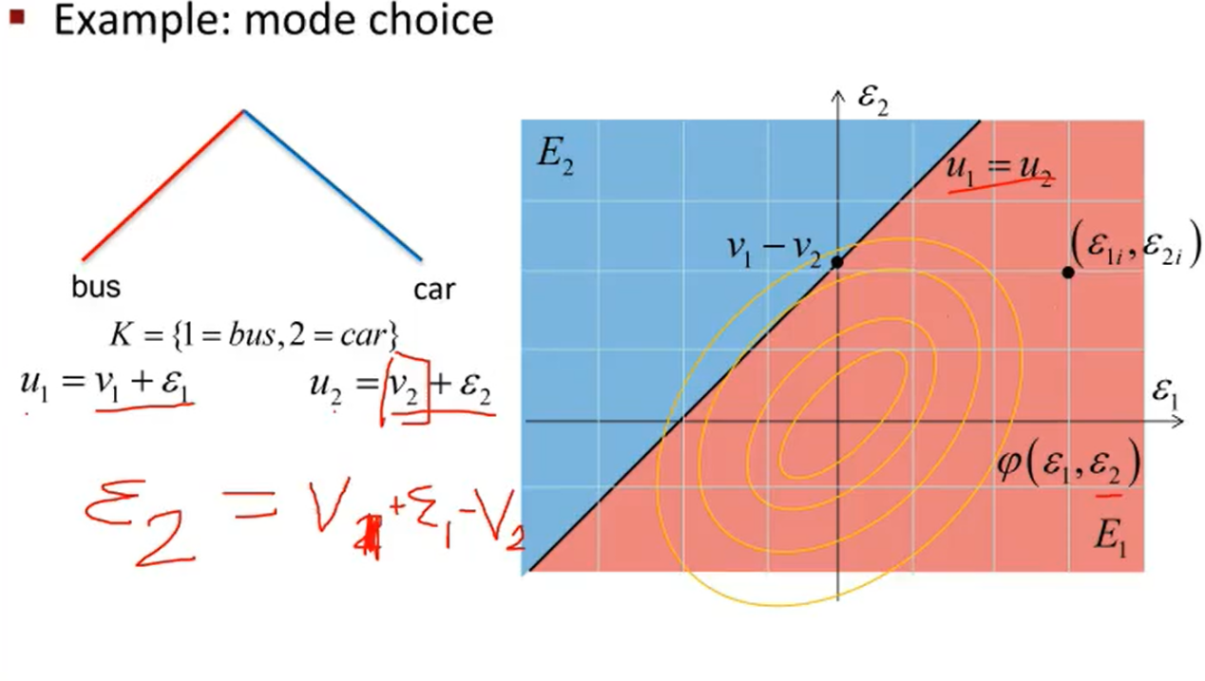

## Joint distribution of random residuals

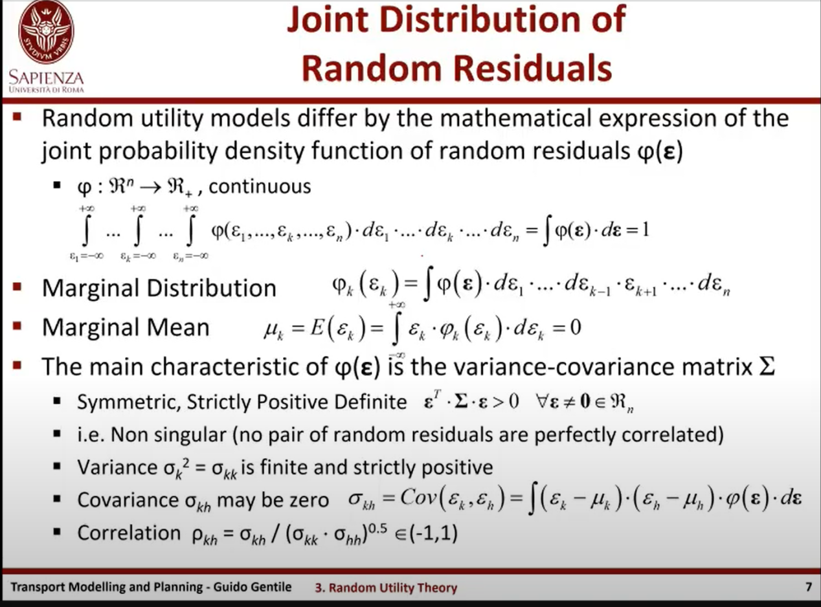

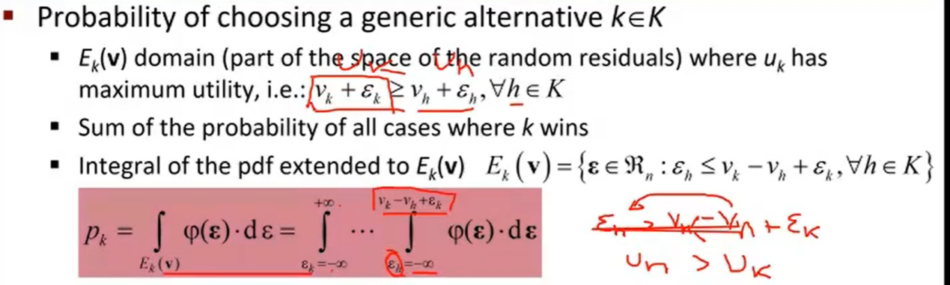

## Probability and satisfaction general formulation

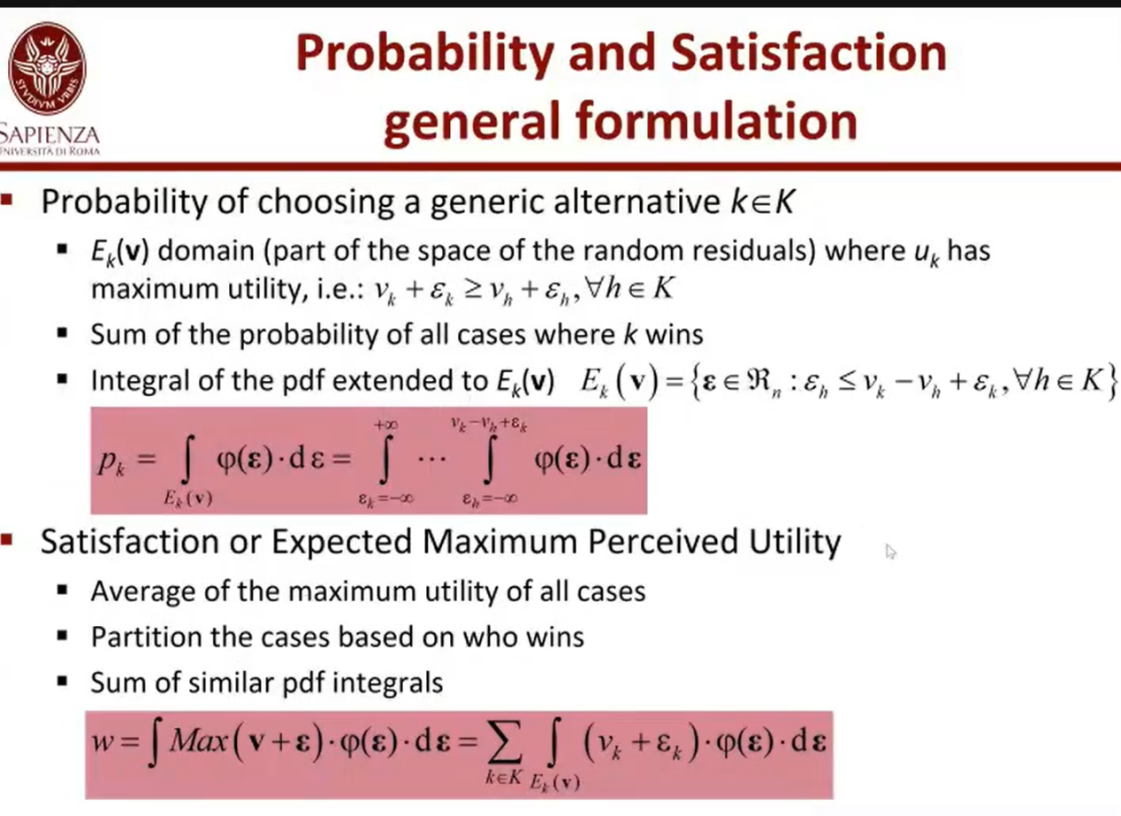

## Mathematical properties

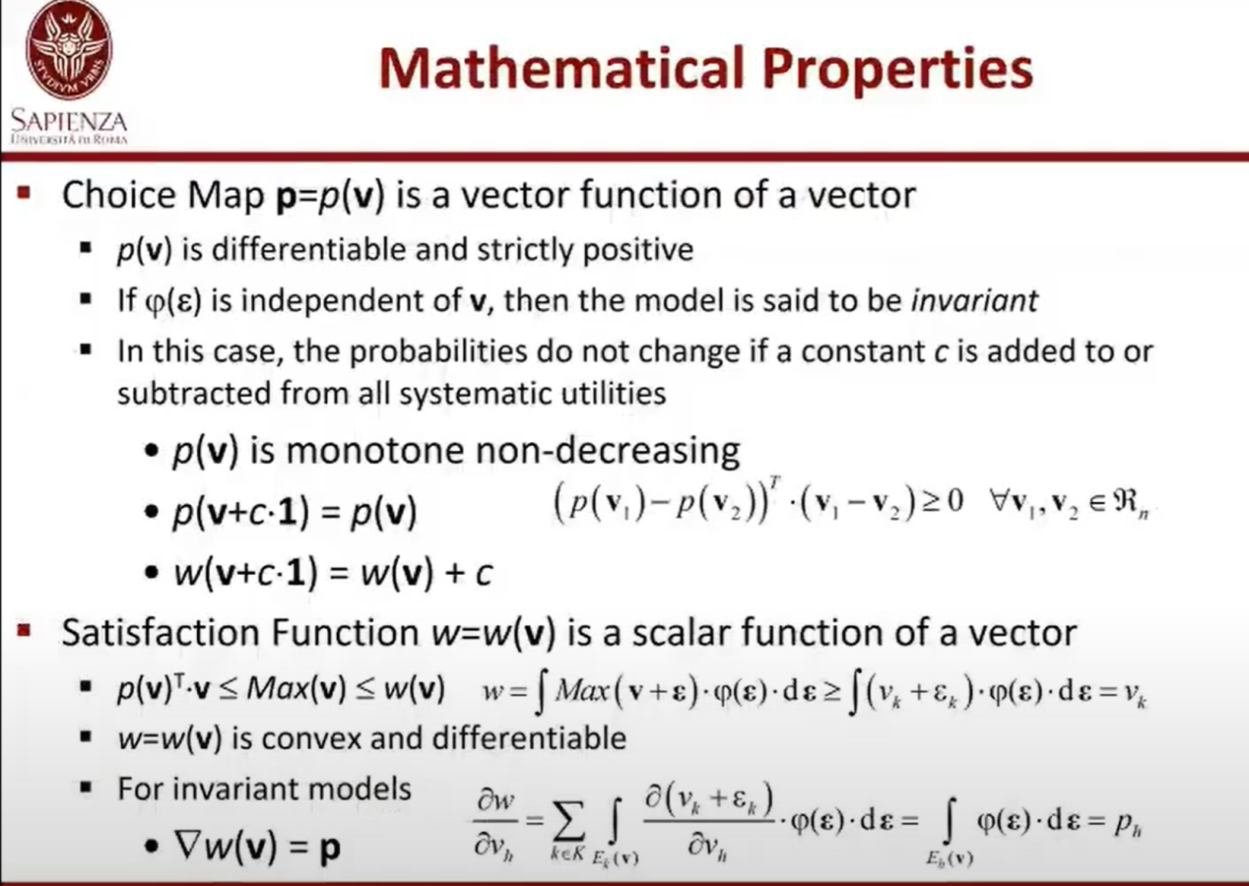



Density

The yellow part is the systematic utility.

